|  |  |
| --- | --- |
| Student Name | **Arbab Hussain Qureshi** |
| Roll Number | **22SW028** |
| Section | **01** |

**DBS LAB # 08 – SubQueries In SQL**

1. Write a query that displays employees whose job title is the same as that of employee 7369 and whose salary is greater than that of employee 7876.

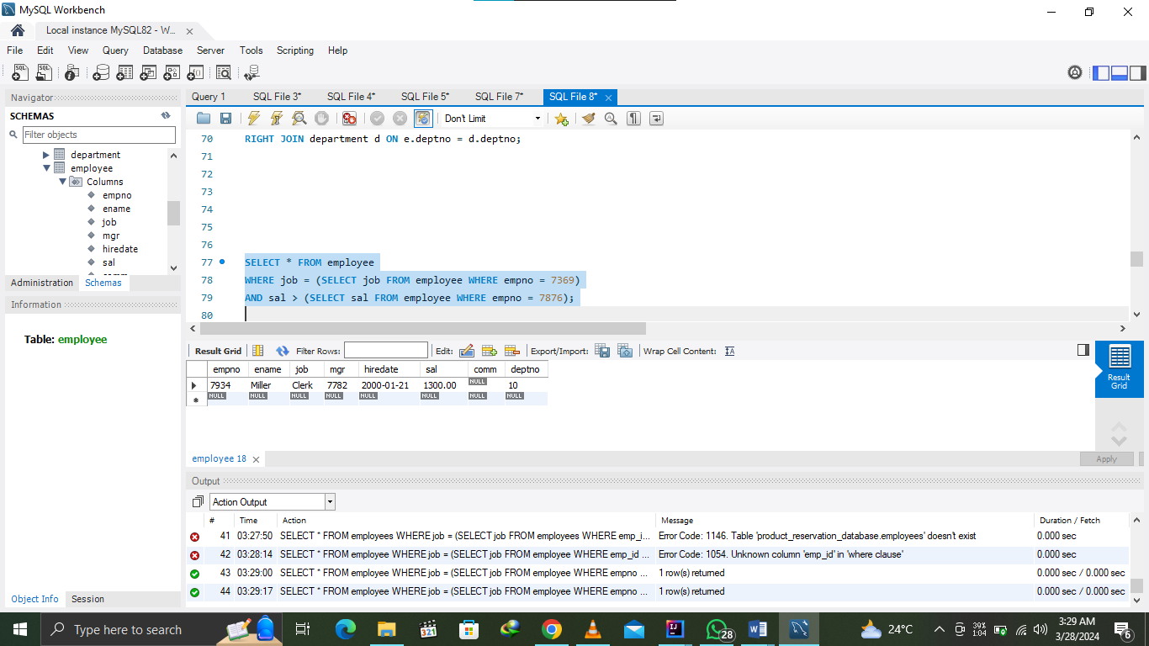

1. Find the job with the lowest average salary.

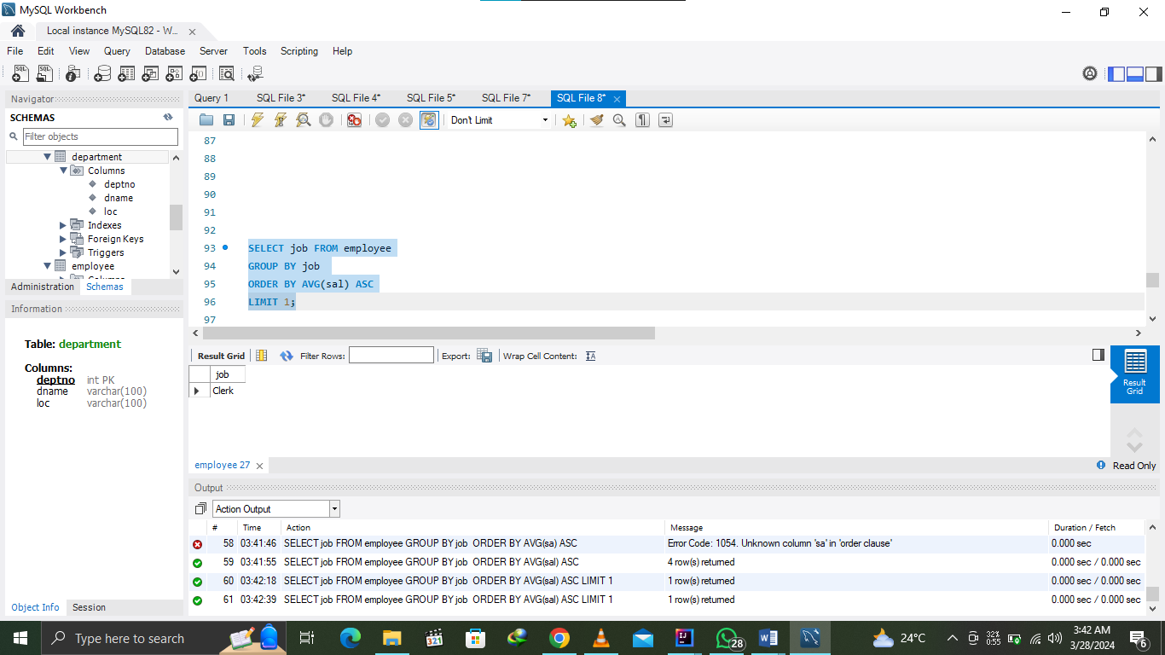

1. Write a SQL statement displays all the employees whose salary is less than any CLERK and who are not CLERK.

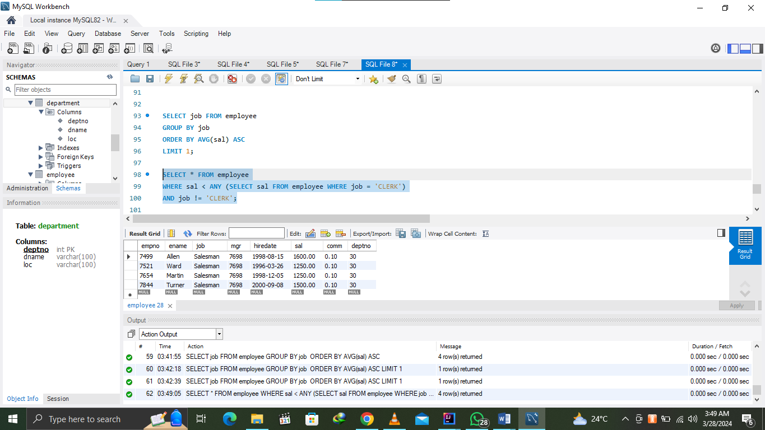

1. Find the employees who earn the same salary as the minimum salary for departments.

Output:

